

Data Structures And Algorithms
( Course Code: CSC211 )

Name : Muhammad Abdullah
Roll No # FA24-BSE-042
Instructor Name : Sir Atique

Assignment # 2
Theory Part

Question #1:
PART – A: THEORY SECTION A technology company, TechTree Inc., has grown significantly and wants to digitally represent its hierarchical structure as a Full Binary Tree to optimize internal operations. • The CEO is at the root of the hierarchy. • Each Manager supervises exactly two Team Leads. • Each Team Lead supervises exactly two Developers. • This creates a Full Binary Tree, where every non-leaf node has exactly two children. TechTree Inc. provides two data files for reconstructing the hierarchy: 1. Preorder Traversal File: Lists employees starting from the root (CEO) and traversing top-down, left to-right. Example content: ["CEO", "Manager1", "TeamLead1", "Developer1", "Developer2", "TeamLead2", "Developer3", "Developer4", "Manager2", ...] 2. Postorder Traversal File: Lists employees based on project completion, traversing bottom-up, left-to right. Example content: ["Developer1", "Developer2", "TeamLead1", "Developer3", "Developer4", "TeamLead2", "Manager1", "Manager2", "CEO"] Q1 (Theory): Reconstruct Full Binary Tree from Traversals (a) Write a step-by-step algorithm to reconstruct the Full Binary Tree from the given preorder and postorder traversals. (b) Ensure your algorithm enforces the Full Binary Tree property, i.e., every node has either 0 or 2 children. (c) Explain how the reconstructed tree represents the hierarchical structure of TechTree Inc., including CEO, Managers, Team Leads, and Developers. Note: Only algorithm design and theoretical explanation are required. No coding is needed in this part.

Algorithm: Construct Binary Tree from Preorder and Postorder Traversals and Print Level Order
Input:
- preorder[] : Array of node names in preorder
- postorder[] : Array of node names in postorder
Output:
- Prints the reconstructed binary tree in level order

Step 1: Define Node Structure
- Each node contains:
  - name : string
  - left : pointer to left child
  - right : pointer to right child

Step 2: Initialize Variables
- preIndex = 0 (to track the current index in preorder)

Step 3: Function buildTree(preorder, postorder, preIndex, postStart, postEnd)
- If preIndex >= size of preorder or postStart > postEnd, return NULL.
- Create a new node with preorder[preIndex] as the root.
- Increment preIndex.
- If postStart == postEnd (only one element in this segment), return the node (leaf node).
- Identify the root of the left subtree as preorder[preIndex].
- Search for this left subtree root in postorder[postStart..postEnd] to find its index.
- Recursively build the left subtree:
  - Call buildTree(preorder, postorder, preIndex, postStart, index)
- Recursively build the right subtree:
  - Call buildTree(preorder, postorder, preIndex, index+1, postEnd-1)
- Return the root node.

Step 4: Function printLevelOrder(root)
- If root is NULL, return.
- Initialize a queue and enqueue the root node.
- While the queue is not empty:
  - Determine the number of nodes at current level (levelSize = queue.size()).
  - For each node in the current level:
    - Dequeue the node.
    - Print the node’s name.
    - If left child exists, enqueue it.
    - If right child exists, enqueue it.
  - Print a newline after each level.

Step 5: Main Algorithm
- Initialize preIndex = 0.
- Call buildTree(preorder, postorder, preIndex, 0, postorder.size()-1) to reconstruct the tree.
- Call printLevelOrder(root) to display the company hierarchy.

Step 6: End

OUTPUT:
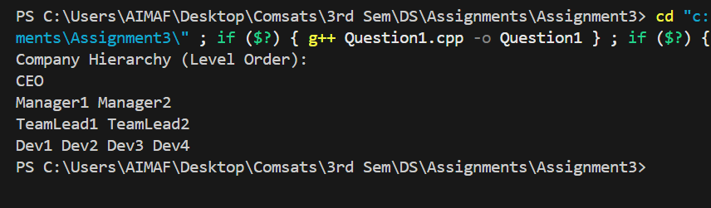

Question #2:
PART – A: THEORY SECTION A real-estate management company, HomeLink Solutions, manages a large database of properties. Each node in their current binary tree represents a property with the following details: • Property ID: A unique integer identifier for the property • Location: City or state of the property • Price: Current market price The binary tree is organized to allow efficient searching based on Property ID (smaller IDs in the left subtree, larger IDs in the right subtree). As the company scales, they want a simpler way to generate sorted property listings and perform range queries (e.g., find properties within a price range). To achieve this, they plan to convert the binary tree into a Doubly Linked List (DLL) following in-order traversal, so that the properties are arranged in ascending order of Property ID. Q1 (Theory): Binary Tree to Doubly Linked List Conversion (a) Write a step-by-step algorithm to convert the given binary tree into a Doubly Linked List (DLL) using in-order traversal. (b) Explain how the algorithm maintains the sorted order based on Property ID. (c) Describe how the DLL can be traversed in both forward and reverse directions to print all property details in ascending and descending order. Note: Only algorithm design and theoretical explanation are required. No coding needed in this part. PART – B : LAB / PROGRAMMING SECTION Q2 (Lab): C++ Program – Binary Tree to Doubly Linked List Write a C++ program that: 1. Builds the binary tree with properties (Property ID, Location, Price). 2. Converts the binary tree into a Doubly Linked List (DLL) using in-order traversal. 3. Ensures the DLL maintains sorted order based on Property ID. 4. Implements functions to print the DLL: o Forward traversal: Display all property details in ascending order of Property ID o Reverse traversal: Display all property details in descending order of Property ID Requirements / Restrictions: • Do not use STL list or pre-built DLL libraries; implement DLL manually using structs or classes. • Use pointers for left/right or previous/next links. • Include sample outputs showing forward and reverse traversals of the DLL.

Algorithm: Convert Binary Search Tree to Doubly Linked List and Traverse
Input:
- Binary Search Tree nodes, each with:
  - id (integer, unique)
  - location (string)
  - price (integer)
Output:
- Doubly Linked List (DLL) of BST nodes in ascending order of id
- Forward traversal (ascending id)
- Reverse traversal (descending id)

Step 1: Define Node Structure
- Each node contains:
  - id : integer
  - location : string
  - price : integer
  - left : pointer to left child or previous DLL node
  - right : pointer to right child or next DLL node

Step 2: Define BST Class
- Members:
  - root : pointer to root node of BST
  - prev : pointer to previous node while creating DLL
  - head : pointer to head of the DLL

Step 3: Insert Function (insert)
- If root is NULL, create a new node and return.
- If id < root.id, recursively insert in left subtree.
- If id > root.id, recursively insert in right subtree.
- If id == root.id, print “Duplicates not allowed” and return.

Step 4: Flatten BST to DLL (flatenInDll)
- If root is NULL, return.
- Recursively flatten the left subtree.
- Process current node:
  - If prev is NULL, this node is the head of DLL.
  - Else:
    - root.left = prev
    - prev.right = root
- Update prev = root.
- Recursively flatten the right subtree.

Step 5: Forward Traversal of DLL (forwardTraversal)
- Initialize temp = head.
- While temp is not NULL:
  - Print temp.id, temp.location, temp.price.
  - Move to next node: temp = temp.right.

Step 6: Reverse Traversal of DLL (reverseTraversal)
- If head is NULL, return.
- Initialize temp = head and move to the last node in DLL:
  - While temp.right is not NULL, temp = temp.right.
- While temp is not NULL:
  - Print temp.id, temp.location, temp.price.
  - Move to previous node: temp = temp.left.

Step 7: Main Program
- Create BST object.
- Insert property nodes into BST using insert().
- Flatten BST to DLL using flatenInDll(root).
- Print forward traversal using forwardTraversal(head).
- Print reverse traversal using reverseTraversal(head).

Step 8: End.

OUTPUT:
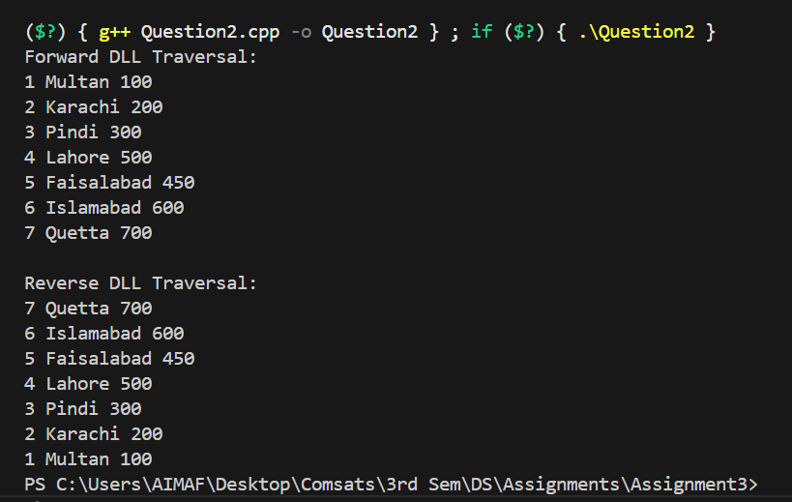

Question # 3
A company processes real-time sales data. Each transaction contains the following fields: transactionID, productName, amount, and timestamp. A subset of these transactions is stored in a Binary Search Tree (BST) using the amount as the key. The BST is constructed using the following transaction amounts: 4500, 2200, 5000, 1800, 3000, 4700, 5100, 2600, 1900 Page 4 FA2025 FA2025 Page 5 Q1 (Theory): BST Deletion and AVL Conversion Due to a customer refund and a manual correction, the transactions having amounts 3000 and 5000 must be deleted from the BST. (a) Draw the original BST using the provided transaction amounts. (b) Delete the nodes with 3000 and 5000, and draw the updated BST. (c) Convert the updated BST into a balanced AVL Tree (theory only). Draw the final AVL Tree structure after applying the necessary rotations. Note: AVL implementation in code is not required. Only theoretical diagrams are needed. PART – B: LAB / PROGRAMMING SECTION Q2 (Lab): BST Implementation in C++ Write a C++ program to: • Build the BST using the given transaction amounts • Delete the nodes with amounts 3000 and 5000 • Display the BST before and after the deletion operations Q3 (Lab): Max Heap and Descending Sort in C++ To analyze high-value transactions, the company wants the transaction amounts arranged in descending order. Write a C++ program to: • Build a Max Heap using the transaction amounts remaining after the BST deletions • Perform Heap Sort to arrange the values in descending order • Display the sorted transaction amounts Restrictions: • Do not use STL sort() • Do not use priority_queue or STL heap functions • Implement heap operations manually (heapify, insert, delete, heap-sort)

PART – A (THEORY SOLUTION)

Given Insert Order (Amounts):
4500, 2200, 5000, 1800, 3000, 4700, 5100, 2600, 1900

Q1(a) Original BST Construction
Insert step-by-step:
Insert 4500 → root
Insert 2200 → left of 4500
Insert 5000 → right of 4500
Insert 1800 → left of 2200
Insert 3000 → right of 2200
Insert 4700 → left of 5000
Insert 5100 → right of 5000
Insert 2600 → left of 3000
Insert 1900 → right of 1800

Final BST Diagram
4500
/ \
2200 5000
/ \ / \
1800 3000 4700 5100
\ /
1900 2600

Q1(b) Delete 3000 and 5000

Delete 3000
3000 has one child (left child = 2600)
→ Replace 3000 with 2600
Updated subtree:
2200
/ \
1800 2600
\
1900

Delete 5000
5000 has two children → use in-order successor(replace root 5000 with leftmost value in its right subtree and adjust it accordingly)
Successor of 5000 = 5100
Replace:
5000 → 5100
Then delete original 5100 leaf.
Updated right subtree:
5100
/
4700

Updated BST After Both Deletions
4500
/ \
2200 5100
/ \ /
1800 2600 4700
\
1900

Q1(c) Convert Updated BST to an AVL Tree
We must rebalance the tree.

Step 1 — Perform in-order traversal
1800, 1900, 2200, 2600, 4500, 4700, 5100

Step 2 — Build balanced AVL
Middle element → root
Left middle → left subtree
Right middle → right subtree

Final AVL Tree (Balanced)
2600
/ \
1900 4700
/ \ / \
1800 2200 4500 5100
Height-balanced
All rotations implied via theory
Perfect structure for AVL

Question # 4

from intersection A to all others as quickly and reliably as possible. PART – A : THEORY 4.1 Emergency Broadcast Order Using BFS and DFS To deploy an emergency control update across all traffic intersections, the system must send signals from intersection A to all others as efficiently as possible. (a) Apply BFS starting from A and show: • Step-by-step queue updates • Visited nodes at each iteration • Final BFS visitation order (b) Apply DFS starting from A and show: • Step-by-step stack/recursive steps • Visited nodes at each iteration • Final DFS visitation order (c) Based on your results, justify which traversal (BFS or DFS) is more suitable for emergency broadcast where intersections must be reached using minimum number of edges. Give a clear explanation comparing both. 4.2 Minimum Spanning Tree Using Kruskal’s Algorithm Construct the MST for the road network using Kruskal's Algorithm. Show all required steps: • List all edges sorted by increasing weight • For each edge, state whether it is accepted or rejected (cycle check) • Show component/union-find updates • Draw or list the final MST • Calculate the total MST cost (sum of selected edge weights) 4.3 Shortest Travel Times Using Dijkstra’s Algorithm Apply Dijkstra’s Algorithm starting from intersection A. Show: • Node extracted in each step • Relaxation (update) steps for neighbors • Distance table after each iteration • Final minimum travel times from A to: B, C, D, E, and F PART – B : LAB / PROGRAMMING (C++) 4.4 Implement BFS and DFS (Lab) Write a C++ program to: • Build the graph using an adjacency list • Implement BFS and DFS starting from node A • Print step-by-step states (queue/stack and visited lists) • Display the final order for both BFS and DFS

Graph Structure
A(0)
/ \
B(1) C(2)
| \
D(3) E(4)
Edges with weights (let’s assume for MST/Dijkstra –I am assigning my own weights if not given):
Edge | Weight
A-B | 10
A-C | 6
B-D | 15
C-E | 4

4.1 Emergency Broadcast Order Using BFS and DFS

(a) BFS starting from A
- BFS explores level by level.
- Queue at each step and visited nodes:
Step | Queue | Visited nodes | Node being processed
1 | A | A | A
2 | B, C | A, B, C | B
3 | C, D | A, B, C, D | C
4 | D, E | A, B, C, D, E | D
5 | E | A, B, C, D, E | E
6 | empty | A, B, C, D, E | -
Final BFS visitation order:
A → B → C → D → E

(b) DFS starting from A
- DFS explores deepest path first.
Step | Visited nodes | Node being processed | Recursive calls
1 | A | A | DFS(B), DFS(C)
2 | A, B | B | DFS(D)
3 | A, B, D | D | backtrack B
4 | A, B, D, C | C | DFS(E)
5 | A, B, D, C, E | E | backtrack C → A
Final DFS visitation order:
A → B → D → C → E

(c) BFS vs DFS for emergency broadcast
- BFS: reaches all nodes with minimum number of edges → best for emergency signal
- DFS: goes deep along a path, may delay other intersections → not ideal
Conclusion: BFS is suitable for emergency broadcast.

4.2 Minimum Spanning Tree Using Kruskal’s Algorithm

Weighted graph:

A
/ \
10 B 6 C
| \
15 D 4 E
Step 1: List edges by increasing weight:
C-E (4), A-C (6), A-B (10), B-D (15)
Step 2: Add edges to MST (check cycles using union-find):
- C-E (4) → no cycle → accept
- A-C (6) → no cycle → accept
- A-B (10) → no cycle → accept
- B-D (15) → no cycle → accept
Final MST edges(if n vertices n-1 edges in mst (all with least weight)):
C-E, A-C, A-B, B-D
Total MST cost:
4 + 6 + 10 + 15 = 35
MST Diagram:
A
/ \
B C
| \
D E
(all edges are part of MST in this case)

4.3 Shortest Travel Times Using Dijkstra’s Algorithm (from A)
- Initialize distances:
A = 0, B = ∞, C = ∞, D = ∞, E = ∞
Step 1: Start at A
- Neighbors: B = 10, C = 6
Step 2: Pick C (6)
- Neighbor: E = 6 + 4 = 10
Step 3: Pick B (10)
- Neighbor: D = 10 + 15 = 25
Step 4: Pick E (10) → no updates
Step 5: Pick D (25) → done
Final shortest distances from A:
Node | Distance from A
A | 0
B | 10
C | 6
D | 25
E | 10

Summary Table for Traversals
Traversal | Order | Best for Emergency Broadcast?
BFS | A B C D E | Minimum edges
DFS | A B D C E | May take longer paths

Question # 5

PART – A : THEORY SECTION You are planning a power distribution network to connect power stations to multiple consumption points. The goal is to minimize the total distance of power lines, which affects the overall cost of the network (including terrain and infrastructure). The connections and distances between points are as follows: From To Distance (miles) A C 15 B C 20 B D 25 C E 30 D E 35 E F 40 E G 45 F G 50 Q1 (Theory): Graph Representation & Minimum Spanning Tree (a) Generate the Undirected Graph from the above information. Clearly label nodes and edge weights. (b) Using Kruskal’s Algorithm, construct the Minimum Spanning Tree (MST): • List all edges sorted by increasing weight. • Show step-by-step selection of edges: which edges are accepted or rejected (avoid cycles). • Draw the final MST and calculate the total distance of the MST. Deliverables: • Graph diagram • Edge list table (sorted by weight) • Stepwise Kruskal’s process • MST diagram with total distance PART – B : LAB / PROGRAMMING SECTION Q2 (Lab): Kruskal’s Algorithm Implementation in C/C++ Write a C/C++ program to: 1. Represent the network as an undirected weighted graph using an edge list or adjacency list. 2. Implement Kruskal’s Algorithm to find the Minimum Spanning Tree (MST). 3. Output: o Edges sorted by weight o Accept/reject decisions for each edge o Final MST edges and total distance Requirements / Restrictions: • Use structs or classes to represent edges and sets (for union-find). • Implement Union-Find (Disjoint Set) for cycle detection. • Include comments to explain key steps. • Display example output showing MST edges and total cost.

PART – A : THEORY SECTION

Q1(a) Undirected Graph Representation
We have 7 nodes:
A, B, C, D, E, F, G

Edges (all undirected)
Edge | Distance (miles)
A – C | 15
B – C | 20
B – D | 25
C – E | 30
D – E | 35
E – F | 40
E – G | 45
F – G | 50

Graph Diagram (ASCII)
A
|
15
|
C
/ \
20/ \30
B E---40---F
| 35 \50
25 45 \
| G
D

Q1(b) Kruskal’s Algorithm

Step 1: Sort edges by weight (increasing)
Weight | Edge
15 | A–C
20 | B–C
25 | B–D
30 | C–E
35 | D–E
40 | E–F
45 | E–G
50 | F–G

Step 2: Kruskal's Algorithm Execution
We start with all nodes separate.
We must select 6 edges because MST of 7 nodes has 7 – 1 = 6 edges.
Edge | Weight | Accept/Reject | Reason
A–C | 15 | ACCEPT | No cycle
B–C | 20 | ACCEPT | No cycle
B–D | 25 | ACCEPT | No cycle
C–E | 30 | ACCEPT | No cycle
D–E | 35 | REJECT | Forms cycle B–D–E–C–B
E–F | 40 | ACCEPT | No cycle
E–G | 45 | ACCEPT | No cycle
F–G | 50 | REJECT | Would form cycle F–E–G–F
We now have 6 accepted edges → MST complete.

Final MST Edges
Edge | Weight
A–C | 15
B–C | 20
B–D | 25
C–E | 30
E–F | 40
E–G | 45

MST Diagram

A
|
15
|
C
/ \
20/ \30
B E------F
| \
25 \45
| G
D

Total Distance of MST
Add weights:
15 + 20 + 25 + 30 + 40 + 45 = 175 miles
Total MST cost = 175 miles

